**Technical Note T10-2022**

February 2022

**BIOVIA LES: Impact of MS Windows security patch KB5004442 on the operation of BIOVIA LES**

Program

BIOVIA LES

Operating System

All supported operating systems

Background

Microsoft has implemented a patch ([KB5004442](https://support.microsoft.com/en-us/topic/kb5004442-manage-changes-for-windows-dcom-server-security-feature-bypass-cve-2021-26414-f1400b52-c141-43d2-941e-37ed901c769c)) for MS Windows DCOM server security and that seems to have an impact on the communication between LES client and LES application server. The patch gets implemented in three phases and during the third phase the following registry key gets enabled:

HKEY_LOCAL_MACHINE\SOFTWARE\Microsoft\Ole\AppCompat\RequireIntegrityActivationAuthenticationLevel

At this point, the value for the key cannot be changed.

Solution

The following workaround is suggested : Setting the DCOM ‘Default Authentication Level’ on the LES Client server to ‘Connect’. Please, follow the steps below:

1. Run the command ‘mmc -32’
2. From File menu, select ‘Add/Remove Snap-ins’.
3. Add ‘Component Services’ and click ‘OK’.
4. Expand ‘Component Services’ to reach ‘My Computer’.
5. Right-click on ‘My Computer’ and select ‘ Properties’. Click ‘Default Properties’ tab.
6. Select ‘Connect’ for ‘Default Authentication Level’. Click OK to save the selection.

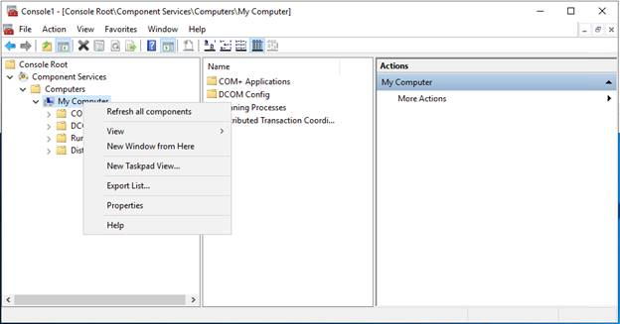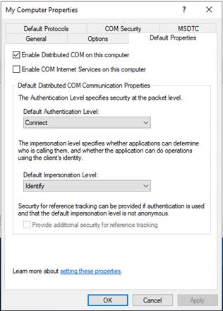

How to contact BIOVIA Support

Please, contact [BIOVIA Support](https://www.3ds.com/support/) in case you experience any issues during file verification and we will work with you to determine if those failures are expected/acceptable to your environment.