**Technical Note T85-2022**

Dec 2022

**BIOVIA IDS: Changing password for System User post installation of BIOVIA IDS**

Program

BIOVIA Instrument Data System (IDS)

Operating System

All supported operating systems

Background

Some customers may require to change the password for ‘System User’ (SUSR) periodically. During IDS installation, ‘System User’ and password is used. The new password must be updated with in IIS and also LES DCOM object. The following error message may appear when launching ‘IDS Web page’.

“Service Unavailable

HTTP Error 503 Service Unavailable”

Solution

To change the password for the SUSR follow the steps provided below. Log into the LES Client/IDS server who has the admin privileges.

1. Change the password for the VQSM.clsDBconnect DCOM object:
   1. Run the command ‘mmc -32’.
   2. From File menu, select ‘Add/Remove Snap-in’.
   3. Add ‘Component Services’ and click ‘OK’.
   4. Expand ‘Component Services’ to reach ‘My Computer’
   5. Expand ‘My Computer’ to access ‘DCOM Config’.
   6. Double-Click on ‘DCOM Config’ and select ‘Details’ from ‘View’.
   7. Navigate to ‘VASM.clsDBConnect’ DCOM object and right-click and select ‘Properties’. Select ‘Identity’ tab.
   8. Add the new password for the SUSR. If no user is added, then select ‘ This User’ and fill the user (domain\SUSR) and password fields.
   9. Click ‘OK’ to complete the change.
2. Changing the password for the ‘IDS Web Service AppPool’.
   1. Open ‘IIS’ (run ‘inetmgr’).
   2. On left pane, Click ‘Application Pools’ and right-click on ‘IDS Web Service AppPool’. Select ‘Advanced Settings’.
   3. Select ‘Identity’ on the list, and click the ellipsis (…). Click ‘Set’ and add the new password for the SUSR.
3. Changing the password in the ‘Authentication’ category.
   1. From the left pane, click on ‘IDS Services’ site (Sites) and on the right, double-click on ‘Authentication’ from the IIS Category.
   2. Right-click on ‘Anonymous Authentication’ and select ‘Edit’. Then click on ‘Set’ for ‘Specific User’.
   3. Add SUSR and new password. Click ‘OK’ to complete.
4. Restart the web service, from ‘Manage Website’.

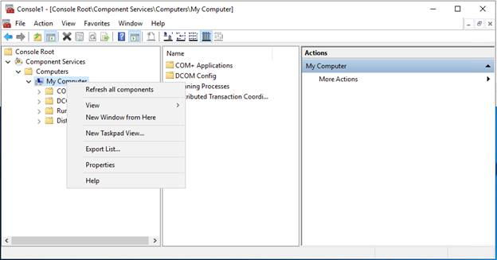 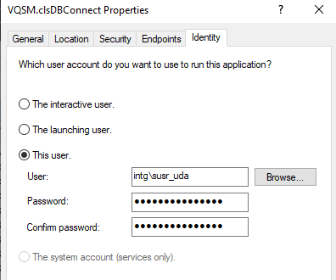

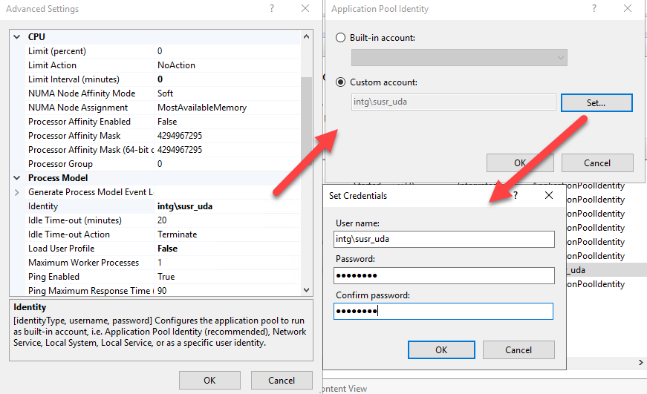

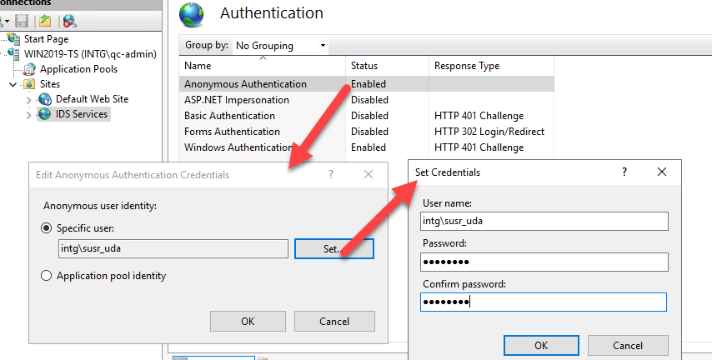

How to contact BIOVIA Support

Please contact [BIOVIA Support](https://www.3ds.com/support/) if you experience any issues.